#### SRI KRISHNA COLLEGE OF TECHNOLOGY

**An Autonomous Institution | Accredited by NAAC with 'A' Grade Affiliated to Anna University | Approved by AICTE**

#### KOVAIPUDUR, COIMBATORE 641042

**GIFT CRAFT MARKETPLACE**

#### A PROJECT REPORT

***Submitted by***

**ABHISHEK.P 727821TUIT005**

**AKSHAYA.D 727821TUIT008**

**HEMAHARSHINI.K.J 727821TUIT035**

***in partial fulfillment for the award of the degree of***

#### BACHELOR OF TECHNOLOGY

#### IN

**DEPARTMENT OF INFORMATION TECHNOLOGY**

#### April 2024

**GiftCraft MarketPlace : A Gift Customization Portal**

**Introduction:**

A digital platform designed to give best gifting experience. It’s a space where users can browse through a vast array of customizable gifts, ranging from jewelry to home decor, all in one convenient location. With intuitive features, users can easily navigate through the portal, selecting and personalizing their chosen items with ease. Our portal aims to simplify the process of finding and creating the perfect gift.

With an intuitive dashboard, administrators can effortlessly add, edit, or remove products, ensuring a dynamic and up-to-date catalog.

**Objective:**

An online customized gift portal is a platform that allows users to create and purchase personalized gifts for various occasions. These portals offer a wide range of customizable products, allowing customers to add their personal touch to gifts.

Build an application that customers can buy customized gifts online. The customers can choose themes, gifts, select gifts, order online. The user will have option to edit and cancel the order.  The order value should be generated automatically. The admin can add new themes, delete the themes, edit the theme details and view themes The admin can also add, edit, view and delete gifts to be customized. Customer can provide reviews.  Customer can make the payments.

**User Flow Chart:**

Login Page

Billing Page

Cart Page

Register Page

**isRegister?**

**isLoggedIn?**

Clicking on **“Add To Cart”**

Home Page

Products Page

**User Modules:**

1. **Home Page:**

The homepage of the gift customization app presents an intuitive interface designed to showcase a wide range of customizable products. Users are greeted with a visually appealing layout that highlights popular and recommended items, enticing them to explore further. The page is structured to provide easy navigation and quick access to product categories, ensuring a seamless user experience.

Key Features:

Product Display: The homepage prominently displays a selection of customizable products, each accompanied by an enticing image, title, price, and the number of customers who have purchased the item. This layout allows users to browse through products at a glance and select those that interest them.

Interactive Elements: Each product is presented within a clickable container, allowing users to view additional details or customize the item further by clicking on it. This interactive feature enhances user engagement and encourages exploration.

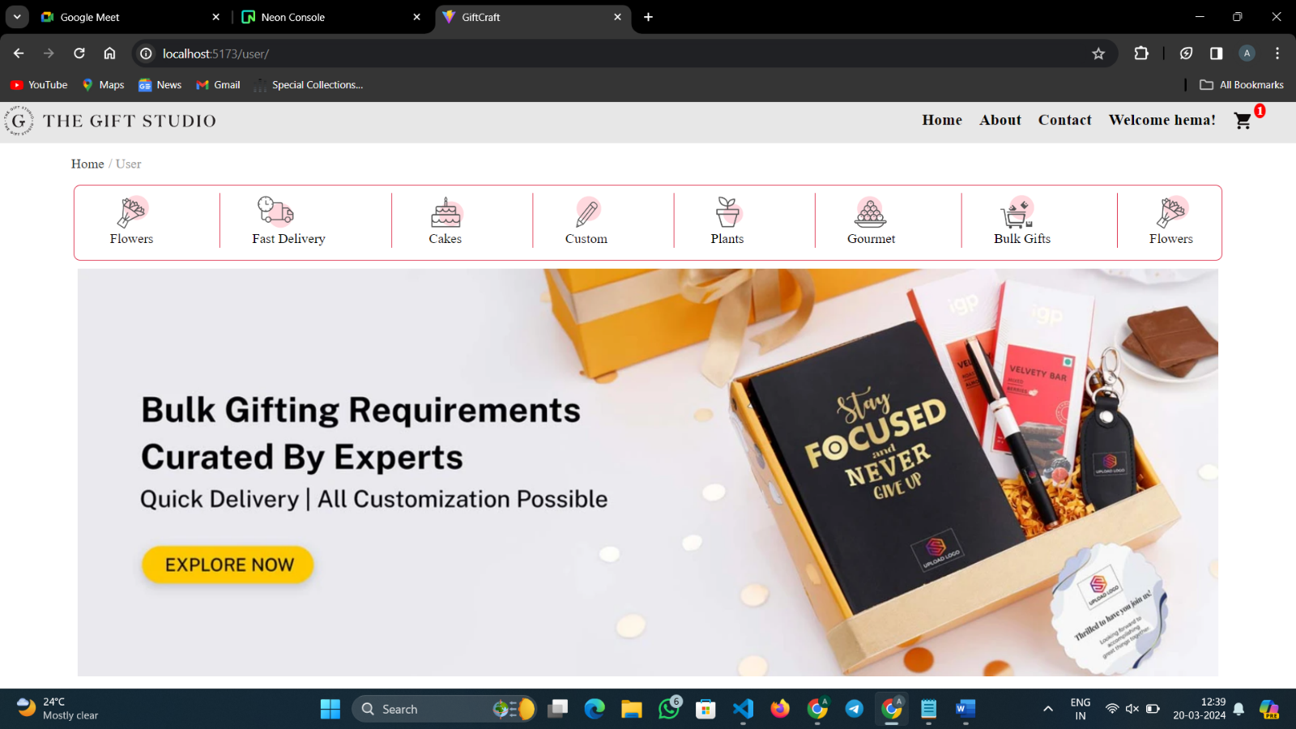

**Home Page**

1. **Products Page:**

The products display page serves as a central hub where users can explore and evaluate a wide range of customizable items offered by the platform. It is meticulously designed to deliver an engaging and intuitive shopping experience, facilitating seamless product discovery and selection.

The page employs a visually appealing grid layout, showcasing multiple products simultaneously in an organized and structured manner. Each product is displayed with its corresponding image, title, price, and other relevant details, enabling users to make informed purchase decisions

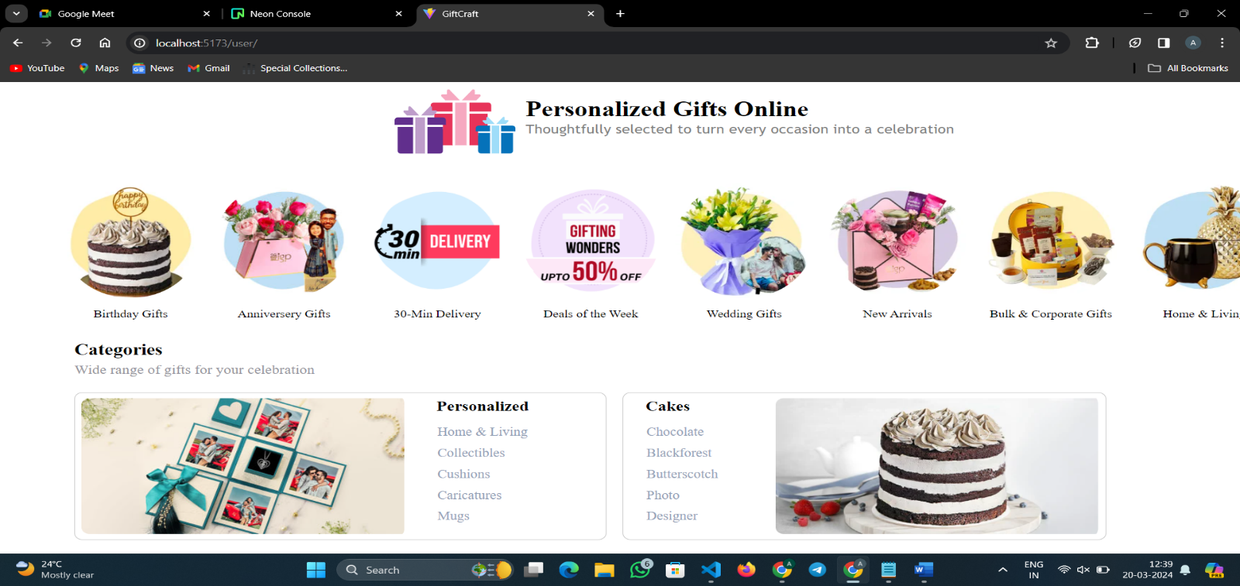

**Products Page**

1. **Footer:**

The footer section of the gift customization app serves as a valuable resource for users, offering essential links and information to enhance their experience and address their queries.

The "Terms and Policy" section directs users to the platform's comprehensive terms of service and privacy policy documents. By accessing these documents, users can familiarize themselves with the terms and conditions governing their usage of the app, as well as the platform's policies regarding data privacy, security, and other relevant aspects.

The "Conditions" section provides users with insights into the terms and conditions applicable to their interactions with the platform, including but not limited to purchasing products, availing services, and engaging in various activities on the app.

The "Return Policy" section outlines the platform's policies and procedures regarding product returns, exchanges, refunds, and related matters. It provides users with essential information on eligibility criteria, timeframes, and processes for initiating and completing return requests. By referring to this section, users can better understand their options and rights in the event of dissatisfaction or issues with their purchases.

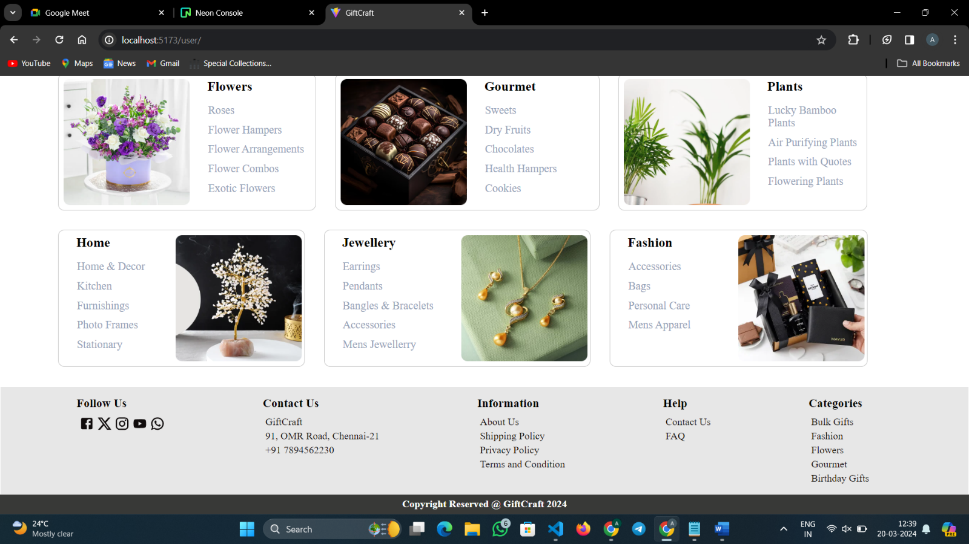

**Footer**

1. **Cart Page:**

The cart page in the gift customization app serves as a central hub where users can review, manage, and finalize their selected items before proceeding to checkout. The cart page displays a comprehensive summary of the products added to the user's shopping cart, including details such as product images, names, quantities, prices, and subtotal amounts. This summary provides users with a clear overview of their selected items, allowing them to verify the accuracy of their choices and make any necessary adjustments.

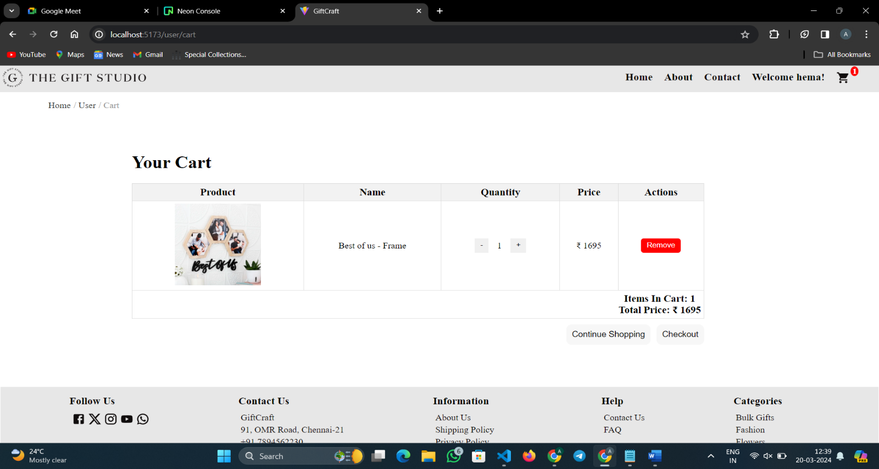

**Cart Page**

1. **Billing Page:**

Billing page epitomizes professionalism and security, serving as the final checkpoint in your purchasing journey. Here, you'll find a meticulously crafted platform designed to instill confidence and trust in every transaction. As you navigate through the checkout process, you'll encounter a comprehensive order summary, providing a detailed breakdown of your purchases, ensuring complete transparency. Input your billing details with peace of mind, knowing that our encrypted payment gateway safeguards your sensitive information with the utmost care and diligence. Verify your shipping address to guarantee the accurate and timely delivery of your order, with the flexibility to make any necessary adjustments effortlessly. Choose from a selection of trusted payment options, including credit/debit cards and secure online payment platforms, tailored to meet your preferences and needs. At every step of the way, our billing page is committed to providing a professional and secure environment, ensuring a seamless and worry-free shopping experience for our valued customers.

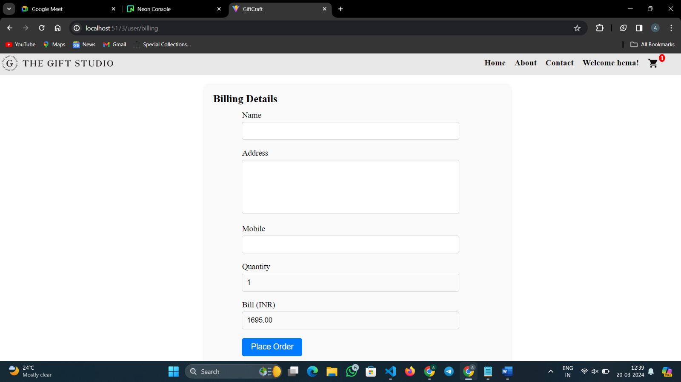

**Billing Page**

**Admin Flow Chart:**

Home Page

Login Page

**isLoggedIn?Admin**

Dashboard

Add Product

User Information

Order List

Add Category

**Admin Modules:**

1. **Dashboard:**

The admin dashboard serves as a centralized control panel for administrators or staff members to manage various aspects of the gift customization platform, including order management. Upon logging into the admin dashboard, administrators are greeted with an overview of essential metrics and insights, providing a snapshot of the platform's performance. This may include key performance indicators such as total sales, number of orders processed, average order value, and other relevant statistics.

A dedicated section within the admin dashboard is reserved for order management. This section allows administrators to view, track, and manage all orders placed by users on the platform. Orders are typically presented in a tabular format, displaying pertinent details such as order ID, date/time of purchase, customer information, order status, and order total.

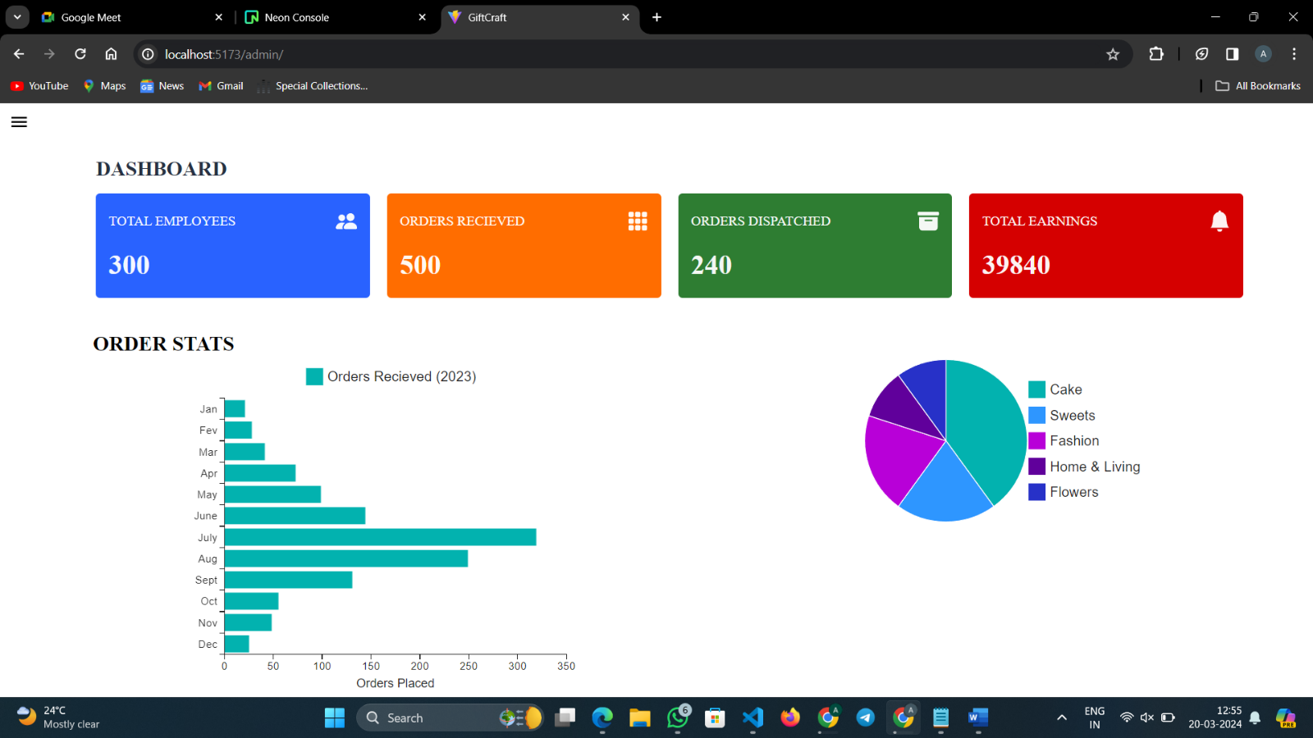

**Dashboard**

1. **Orders List:**

The Order List page serves as a pivotal component within our platform, offering administrators a comprehensive overview of all orders processed through our system. Meticulously designed to facilitate efficient order management, this page provides a centralized hub where administrators can effortlessly navigate, analyze, and take action on orders in real-time. With its intuitive interface and customizable features, the Order List empowers administrators to quickly search, filter, and sort through orders based on various criteria such as order status, date, and customer information. From this centralized dashboard, administrators can access detailed order summaries, track order progress, and manage order fulfillment processes with precision and ease. Whether it's processing new orders, updating order statuses, or resolving customer inquiries, the Order List streamlines the entire order management workflow, ensuring seamless operations and exceptional customer service. With a steadfast commitment to professionalism and efficiency, our Order List page stands as a testament to our dedication to delivering unparalleled order management capabilities within our platform.

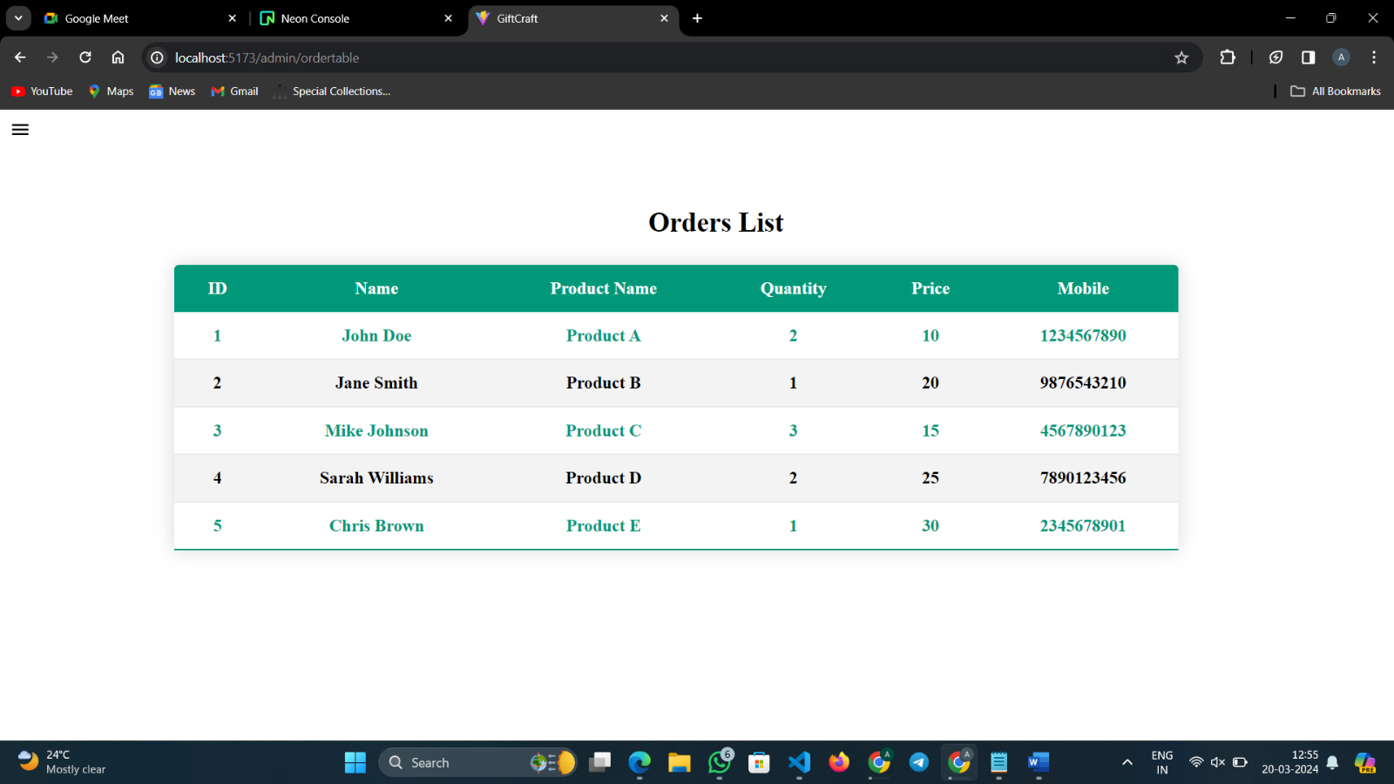

**Order List**

1. **Add Product Page:**

In the admin dashboard, administrators can add new products to the platform, which will be reflected on the user side for browsing and purchasing.On the "Add Product" page, administrators will find a form or input fields to enter product details.

Provide the necessary information such as product name, description, price, quantity, category, and any other relevant attributes.

Upload images of the product to showcase its appearance to users.Once all required product details have been entered, review the information for accuracy.

Click on the "Submit" or "Add Product" button to save the new product to the system.

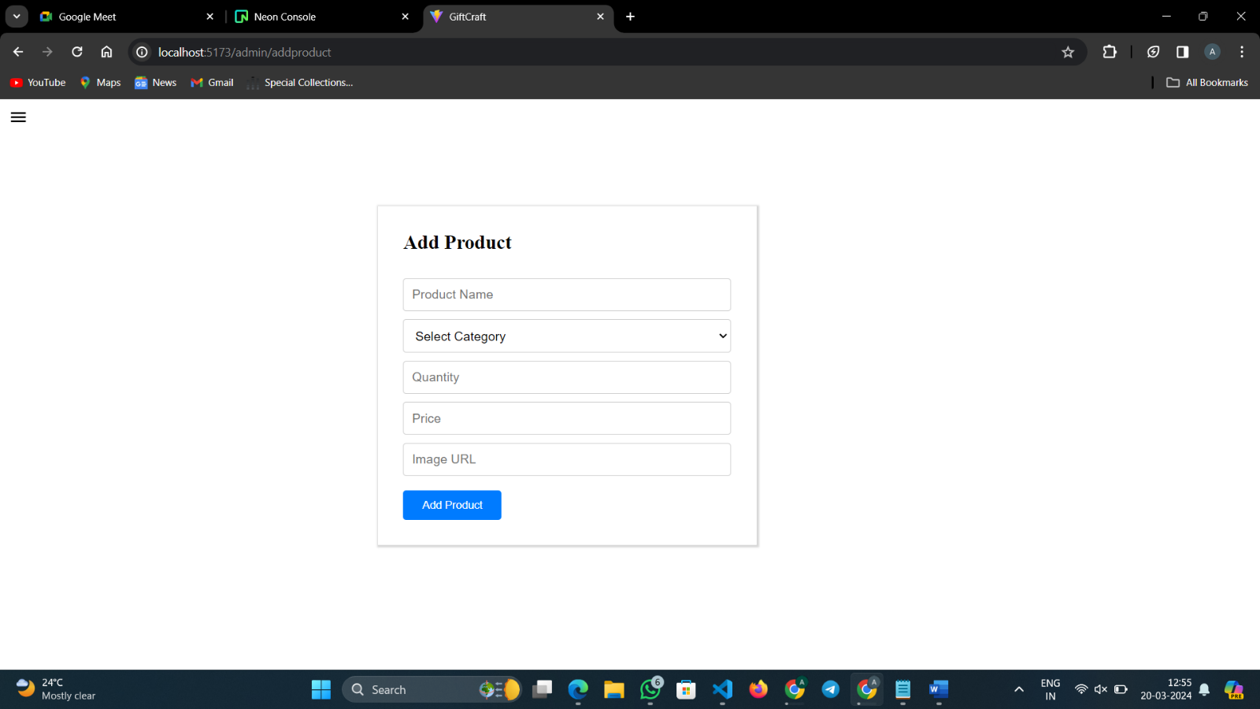

**Add Product Page**

1. **User List:**

The User List feature epitomizes professionalism and efficiency within our platform, providing administrators with a comprehensive overview of all registered users. Designed with meticulous attention to detail, it serves as a centralized hub for user management, enabling administrators to effortlessly navigate, search, and filter through the user database. From this centralized interface, administrators can access detailed user profiles, view account information, and manage user permissions with ease. With its intuitive design and customizable functionality, the User List empowers administrators to efficiently perform tasks such as user onboarding, account maintenance, and access control, ensuring smooth and seamless user management processes. Whether it's monitoring user activity, analyzing user demographics, or facilitating communication, the User List serves as an indispensable tool for optimizing user management workflows and enhancing overall platform efficiency. With a commitment to professionalism and user-centric design, our User List feature sets the standard for streamlined user management within our platform.

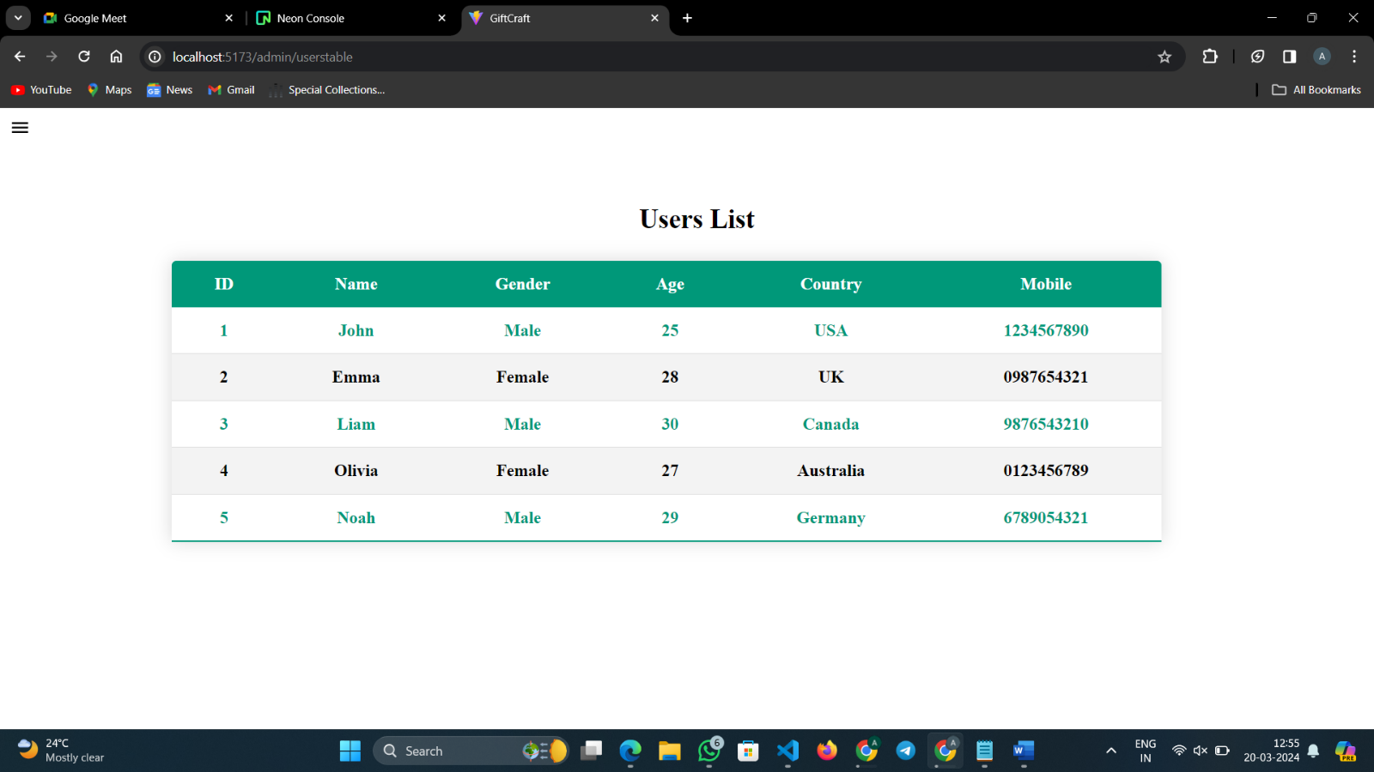

**User List Page**

1. **Sidebar:**

Admin Sidebar stands as a cornerstone of efficient navigation and management within our platform, embodying professionalism and functionality at every turn. Seamlessly integrated into our administrative interface, it offers a comprehensive array of tools and resources meticulously curated to streamline administrative tasks and enhance productivity. With its intuitive design and user-friendly interface, the Admin Sidebar empowers administrators to effortlessly access key features, manage user accounts, monitor analytics, and oversee essential functions with precision and ease. From customizable widgets to insightful data visualization, every element of the Admin Sidebar is thoughtfully crafted to deliver a seamless and intuitive user experience, enabling administrators to effectively manage and optimize their workflows. With a commitment to excellence and innovation, our Admin Sidebar sets the standard for professional administrative tools, ensuring that every interaction is as efficient and productive as possible.

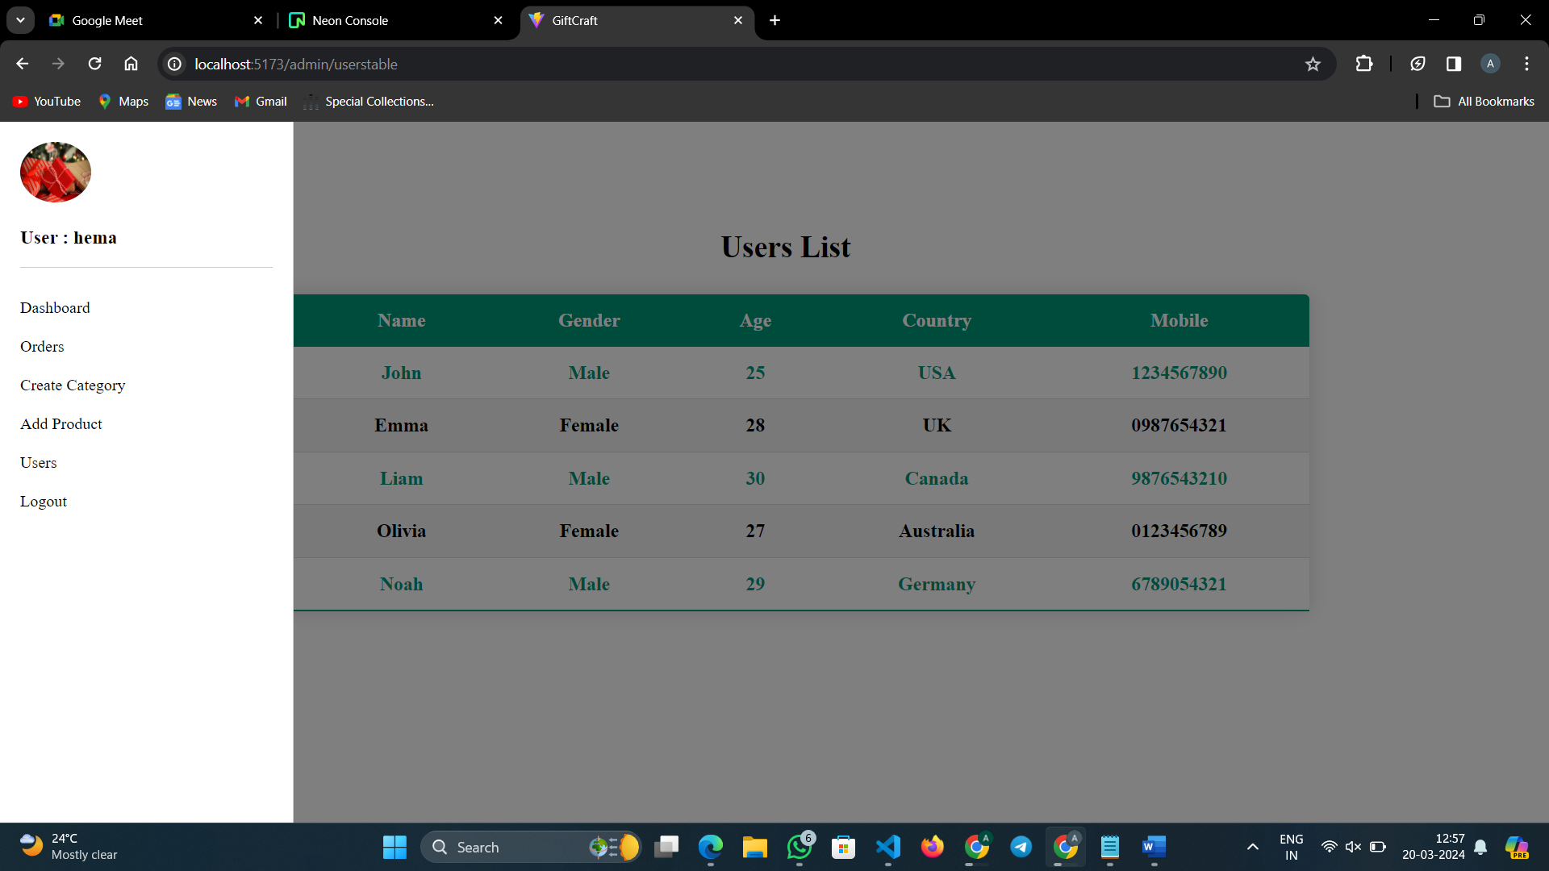

**Admin Side Bar**

**Conclusion:**

The gift customization app allows users to create personalized gifts by customizing various items like mugs, keychains, and more. Users can register, browse products, customize them with messages and images, and place orders securely. The app also includes features like order tracking, social media sharing, and essential links for user support. Overall, it offers a convenient platform for creating unique and thoughtful gifts for any occasion.